**Practice SQL date:19/01/2023**

* create database java_Vikky;
* use java_vikky;
* create table student(student_id int, student_gender char, student_class varchar(20), student_phone_number int,student_village varchar(30));
* insert into student values(1, 'M', '8th class', 9568456, 'putlagudem');
* show tables;
* select * from student;
* insert into student values(2, 'F', '7th class', 9568526, 'Chintapalli');
* insert into student values(3, 'M', '6th class', 8768456, 'Cherukumpalem');
* insert into student values(4, 'F', '9th class', 3698456, 'Kottapalli');
* show tables;
* select*from student;
* select *from student where student_gender ='M';
* select *from student where student_id = 2;
* select *from student where student_phone_number = 8768456;
* select *from student where student_village = 'putlagudem';
* select *from student where student_village = 'atchampet';
* select *from student where student_class = '8th class';
* create table Employee(emp_id int, emp_name varchar(50), emp_gender char, emp_phone_nember bigint, emp_department varchar(20), emp_organsation varchar(50),emp_designation varchar(20), emp_village varchar(30));
* insert into employee values(1,'Pavan Kumar', 'M', '9160260888', 'sales', 'Big C', 'asst manager', 'Putlagudem');
* insert into employee values(2,'Pardhu', 'M', '9989933370', 'Finance', 'HDFC', 'manager', 'Hyderabad');
* insert into employee values(3,'Gnana Vikas', 'M', '9160454544', 'Finance', 'HDFC', 'DGM', 'Hyderabad');
* insert into employee values(4,'Triveni', '^F', '9160454544', 'Finance', 'HDFC', 'CEO', 'Hyderabad');
* show tables;
* select *from employee;
* select *from employee where emp_gender = '';
* select *from employee where emp_gender = 'M';
* select *from employee where emp_gender = 'F';
* select *from employee where emp_phone_nember = 9160260888;
* select *from employee where emp_department = 'sales';
* select *from employee where emp_organsation = 'HDFC';
* select *from employee where emp_designation = 'Manager';
* select *from employee where emp_department = 'finance';
* select *from employee where emp_department = 'sales';
* insert into student(student_id , student_gender , student_class , student_phone_number ,student_village ) values(6, 'F', '5th class', 985222, 'Putlagudem');
* select *from student;
* select *from student where student_village = 'putlagudem';
* select *from employee where emp_id = 3;
* select *from student where student_id = 2;
* 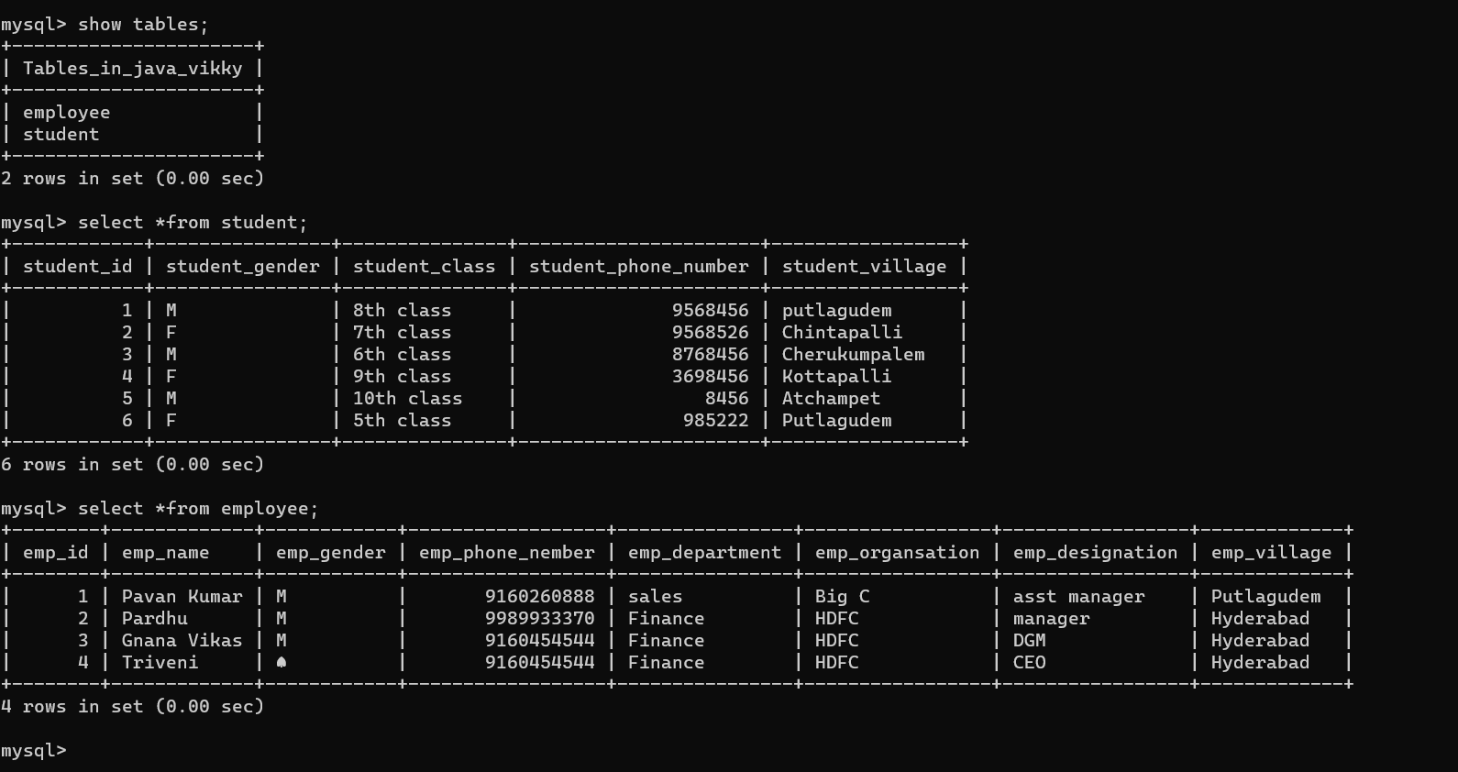

-----------------------------------------------------------------------------------------------------------------

Date:**21/01/2023**

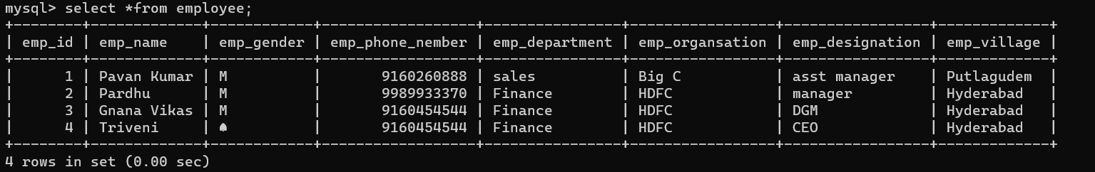

1. **update employee set emp_department = 'IT' where emp_id =2;**

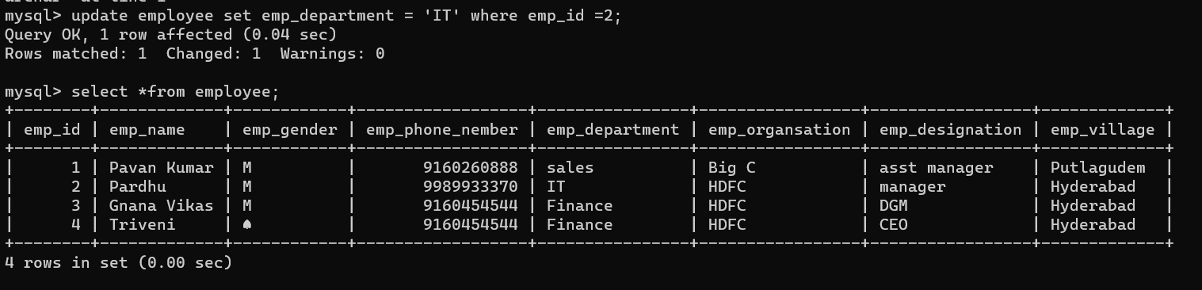

1. **update employee set emp_name = 'Rajya Lakshmi' where emp_id = 1;**

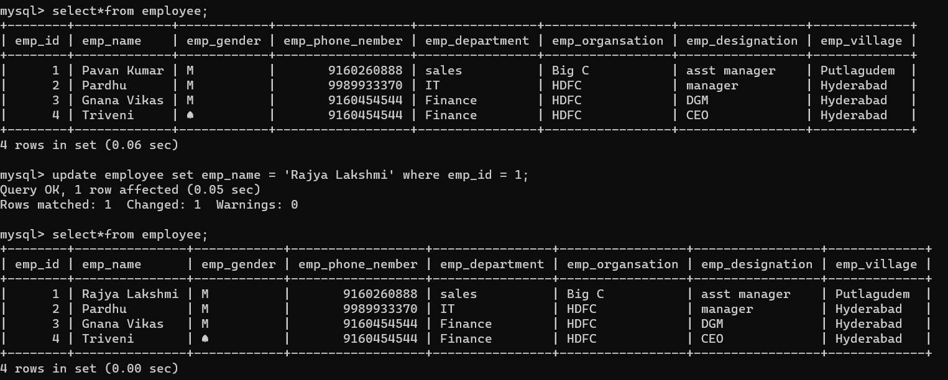

1. **delete** **from employee where emp_name = 'pardhu';**

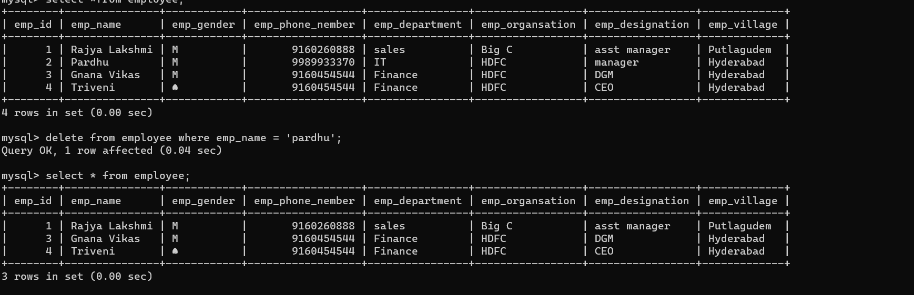

1. **delete from employee;**

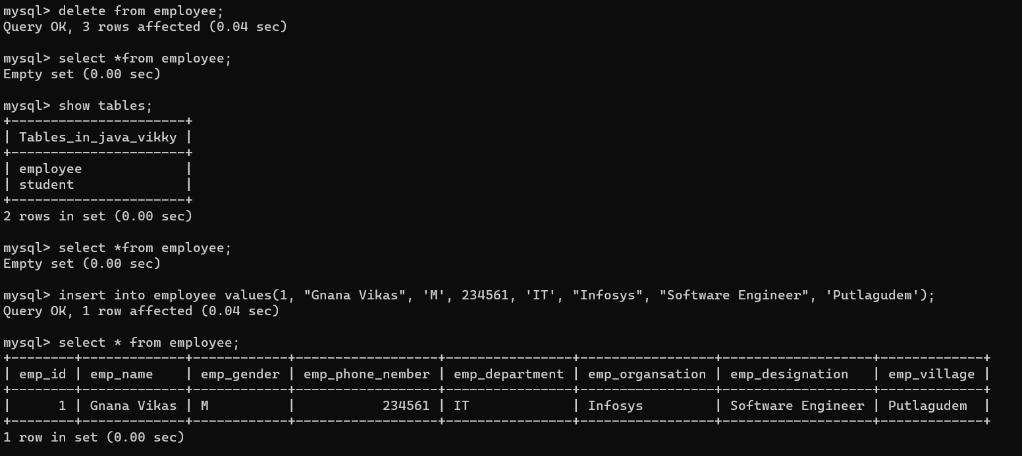

1. **drop table employee;**

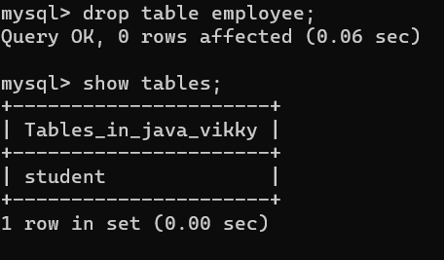

1. **update employee set emp_salary = 150000.00;**

